

Model: PM250-120V/ PM250-220V

Professional Compressor

For Sport

INSTRUCTIONS

IMPORTANT
Please make certain that the person who is using this equipment will read carefully and understand these instructions before starting operations.

SAVE THIS INSTRUCTION FOR FUTURE REFERENCE.

SPECIFICATIONS
PM250-120V：
Rated Voltage | AC100~120V
Max.Current | 0.9A
Rated Power | 85W
Max.Pressure | 60PSI/4.14BAR/4.2 (kg/cm2 )

PM250-220V：
Rated Voltage | AC 220~240V
Max.Current | 0.5A
Rated Power | 95W
Max.Pressure | 60PSI/4.14BAR/4.2 (kg/cm2 )

INSTALLATION
: To Reduce the Risk of Electric Shock or Injury, Use Indoors Only. Do not expose to rain. Store indoors only

Location of the Air Compressor:
Locate the inflator in a clean, dry and well-ventilated area. The inflator should be located at least 12" away from the wall or other obstructions that will interfere with the flow of air. The air compressor is designed to allow for proper cooling. The ventilation openings on the compressor are necessary to maintain proper operating temperature. Do not place rags or other containers on or near these openings.
SAFETY INSTRUCTIONS
CAUTION: When using this equipment, basic safety precautions should always be followed to reduce risk of fire, electric shock, and personal injury or damage to the equipment.
- CONSIDER WORK AREA ENVIRONMENT.
-Don’t expose compressor to rain
-Don’t use compressor in damp or wet locations. Keep work area well lit.
-Don’t use tools in the presence of flammable liquids or gases. Motors in compressor normally spark, and the sparks might ignite fumes.
2. KEEP OTHER PERSONS AWAY.
-Don’t let persons, especially children, not involved in the work touch the compressor or the extensions cord and keep them away from the work area.
3. STORE IDLE TOOLS.
-When not in use, tools should be stored in a dry, locked-up place-out of children’s reach.
4. Don’t ABUSE CORD.
-Never carry by cord or yank it to disconnect from receptacle. Keep cord from heat, oil or sharp edges.
5. MAINTAIN COMPRESSOR WITH CARE.
-Inspect compressor periodically and if damaged have repaired by authorized service facility.
GROUNDING
This product must be grounded. In the event of an electrical short circuit, grounding reduces the risk of electric shock by providing an escape wire for the electric current. This product is equipped with a cord having a grounding wire with an appropriate grounding plug. The plug must be plugged into an outlet that is properly installed and grounded in accordance with all local codes and ordinances.

For example, PM250-120V is for use on a nominal 120V circuit and has a grounding plug similar to the plug illustrated in sketch A in Figure 1. Only connect the product to an outlet having the same configuration as the plug. Do not use an adapter with this product.
Note:
Due to the different types of power connectors used in each country, please purchase the correct voltage and power connector products according to each country.

INFLATING ACCESSORIES
This air inflator includes three accessories:
- Universal Inflating Nozzle, for use with such items as Air Mattresses & Beach Balls.
- Air Nozzle, for use where an air stream is desired, i.e.: dusting or cleaning purpose.
- Needle Inflator Nozzle, for use with such items as Basket Balls, Footballs and Volley Balls.
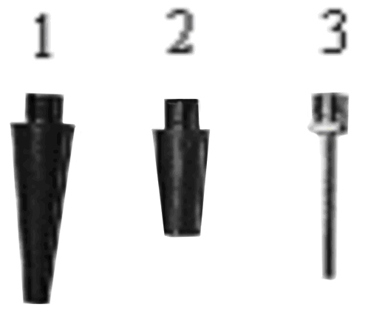
1 2 3
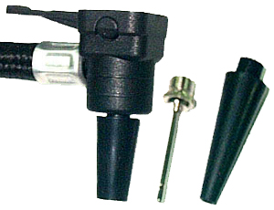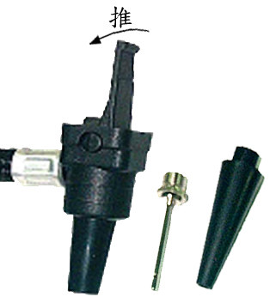
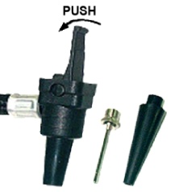

OPERATION
The motor will automatically restart without warning if plugged in electrical outlet and switch is in the ON position.
1. Depending upon the item being inflated, attach the Universal Thumb Latch Valve Adapter directly to the item or to the appropriate inflating accessory.
2. If it is used without an accessory, simply push the Adapter down over the threaded portion of the tire valve with the lever in the upright position, and lock in place by depressing the lever down towards the hose side of the adapter. If one of the accessories is being used, lock the Universal Thumb Latch Valve Adapter to the accessory in the same manner.
3. Plug the unit in and press the On/Off switch to the “On” position. The unit will begin to inflate immediately. When pressure has reached the desired level, turn the unit off. The pressure should be checked with the unit off. If on inspection you find that the correct level has not been reached, turn the unit “On” and repeat the procedure.
4. Set the switch to “OFF” position if completed inflation.
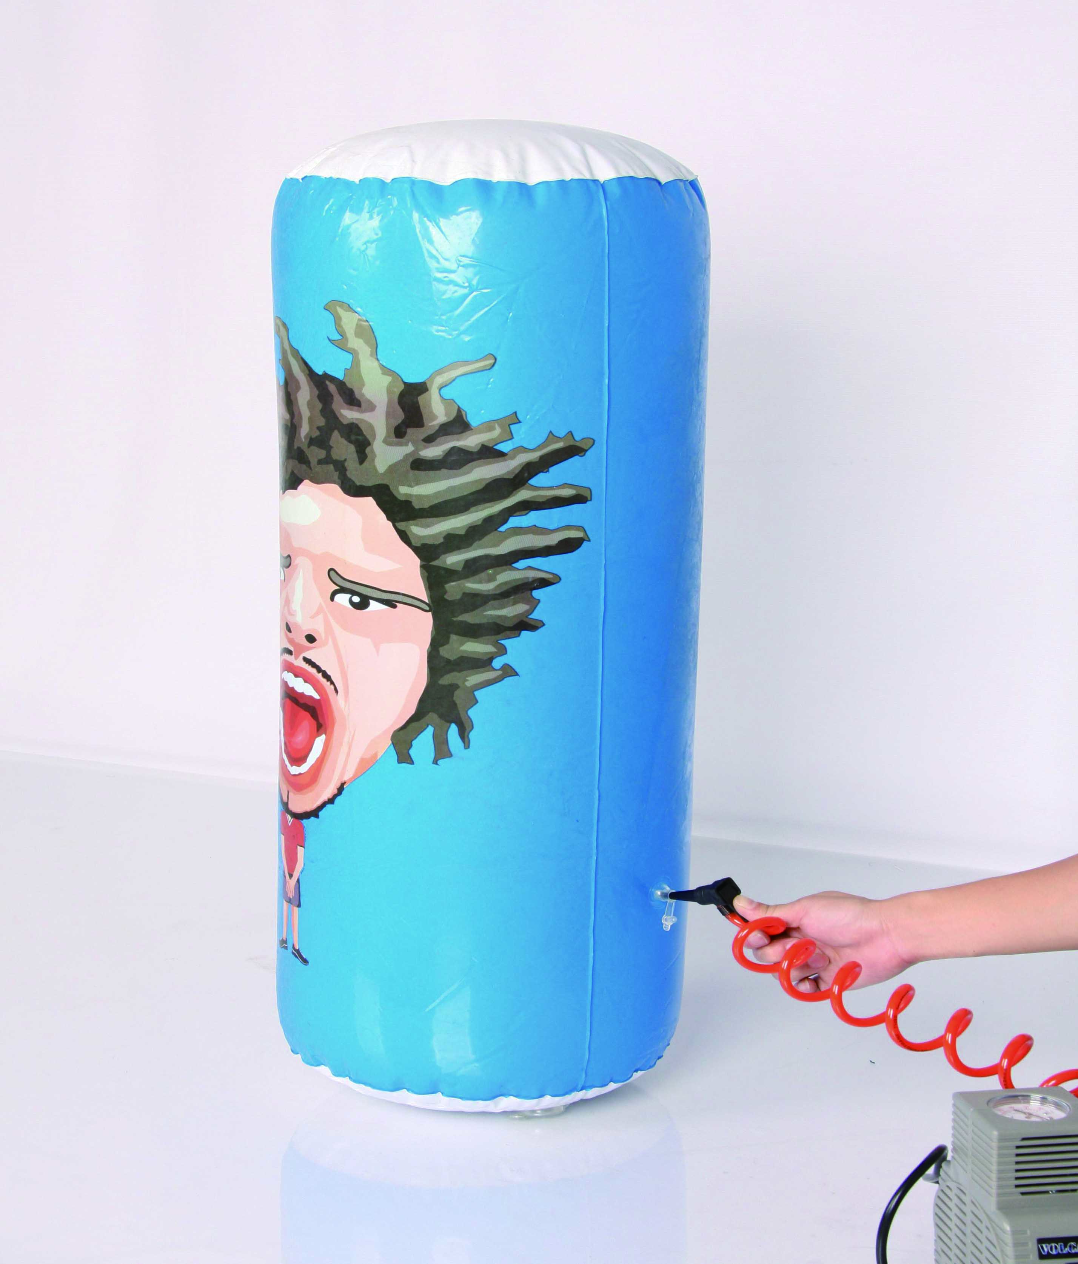
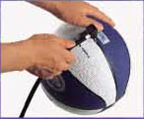
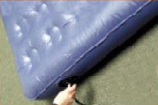

MAINTENANCE & STORAGE
1. This tire inflator is equipped with permanently lubricated, maintenance free motor. Never try to lubricate compressor.
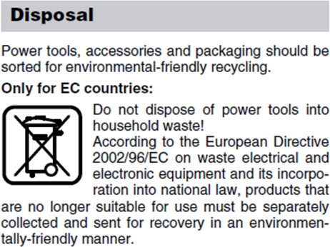
2. Store the air compressor in a clean and dry location.
ALL MAINTENANCE AND REPAIR OPERATIONS NOT LISTED MUST BE PERFORMED BY TRAINED SERVICE TECHNICIAN.
